**TIC TAC TOE WEB APPLICATION**

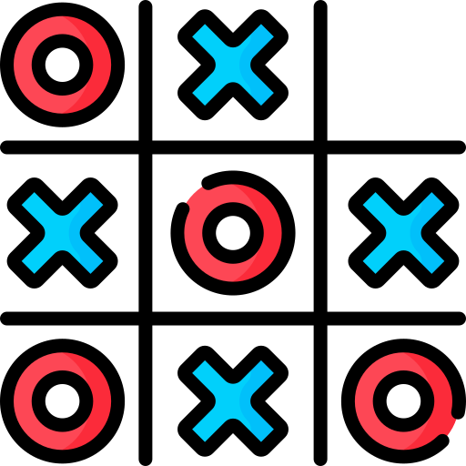

**1. Project Overview**

The **Tic Tac Toe** web application is an interactive multiplayer game that allows two players to play in real time. It is built using **Java Servlets**, **JSP**, and the **Maven** framework for backend development, with a modern and responsive frontend design. The project emphasizes user-friendly gameplay, efficient session management, and scalable architecture.

## ****2. Key Features of Tic Tac Toe****

**Core Gameplay**

* **Multiplayer Mode**: Supports two players in a single game session.
* **Game Logic**: Automatically detects and declares a winner, or identifies a tie.
* **Move Validation**: Prevents invalid or repetitive moves with friendly error messages.
* **Game Reset**: Players can restart the game at any point after completion.

**Innovative Enhancements**

* **Real-Time Updates**: The game board refreshes dynamically after every move.
* **Responsive Design**: Works seamlessly across devices with different screen sizes.
* **Session Persistence**: Ensures all game states are preserved within a single session.

**3. Technology Stack**

**Backend**

* **Java Servlets**: For handling server-side logic and user requests.
* **JSP (JavaServer Pages)**: For rendering dynamic content.
* **JDBC**: For connecting to the SQL database to manage user and game data.

**Frontend**

* **HTML5 & CSS3**: For structuring and styling the web pages.
* **JavaScript & jQuery**: For enhancing interactivity and dynamic behavior.

**Tools & Frameworks**

* **Maven**: Manages dependencies and builds the project.
* **JUnit**: Provides robust unit testing for backend logic.

## ****4. Functional Modules****

**User Authentication**

* **Login and Registration**: Users can log in or register securely.
* **Session Tracking**: Ensures only authenticated users can access the game.

**Game Mechanics**

* **Real-Time Gameplay**: Tracks and validates moves for both players.
* **Result Computation**: Automatically determines the winner or a tie.
* **Reset Functionality**: Allows restarting the game within the same session.

**Database Management**

* **User Data**: Stores and retrieves user credentials.
* **Game Statistics**: (Optional) Tracks games played, wins, and losses for analysis.

## ****4. Functional Modules****

The Tic Tac Toe application consists of several functional modules that work together to deliver an engaging and seamless experience. Each module focuses on a specific aspect of the application, ensuring modularity and maintainability.

**4.1 User Management**

* **Registration Module**:
  + Allows new users to create accounts with basic validation for username, email, and password.
  + Prevents duplicate usernames and invalid entries.
* **Login Module**:
  + Authenticates users with secure credential validation.
  + Displays error messages for invalid login attempts.
* **Session Management**:
  + Maintains user sessions to track logged-in status and ensure secure access to gameplay features.

**4.2 Game Logic Module**

* Implements core game rules, such as:
  + Validating player moves.
  + Checking for winning conditions (rows, columns, diagonals).
  + Detecting ties when all cells are filled without a winner.
* Handles turn alternation between Player X and Player O.
* Provides real-time updates on the game state.

**4.3 Gameplay Interface Module**

* **Frontend Interaction**:
  + Displays the game board and updates it dynamically based on player moves.
  + Shows real-time feedback, such as "Player X's Turn" or "Game Over".
* **Result Handling**:
  + Notifies players of the game result (Win, Lose, Tie) at the end of the game.
  + Offers an option to reset the game board and start a new session.

**4.4 Data Management Module**

* **User Data Handling**:
  + Stores and retrieves user credentials securely using a database.
  + Ensures data consistency during registration and login.

.

**4.5 Error Handling and Validation Module**

* Validates inputs for registration and login (e.g., non-empty fields, email format).
* Prevents invalid gameplay actions, such as:
  + Playing out of turn.
  + Clicking on already filled cells.
* Displays user-friendly error messages for smooth troubleshooting.

## ****5. Testing****

The Tic Tac Toe application underwent comprehensive testing to ensure functionality, reliability, and a seamless user experience.

**5.1 Unit Testing**

* Tested game logic methods such as move validation, win detection, and tie conditions.
* Verified session management to maintain game state during gameplay.
* Example: Ensured the checkWinner() method correctly identifies winning patterns or a tie.

**5.2 Service Layer Testing**

* Validated database operations for user registration, login, and session handling.
* Tested the JDBC connection for robustness and appropriate error handling.
* Example: Ensured login functionality only authenticates valid credentials.

**5.3 Integration Testing**

* Verified end-to-end workflows, such as user login, gameplay updates, and result display.
* Ensured smooth interaction between the frontend (JSP) and backend (Servlets).
* Example: Checked if user actions (e.g., making a move) correctly update the game state in real time.

**5.4 UI/UX Testing**

* Ensured the interface is responsive and functional across various devices and browsers.
* Verified error messages for clarity and accuracy (e.g., invalid login or duplicate moves).

**REGISTRATION**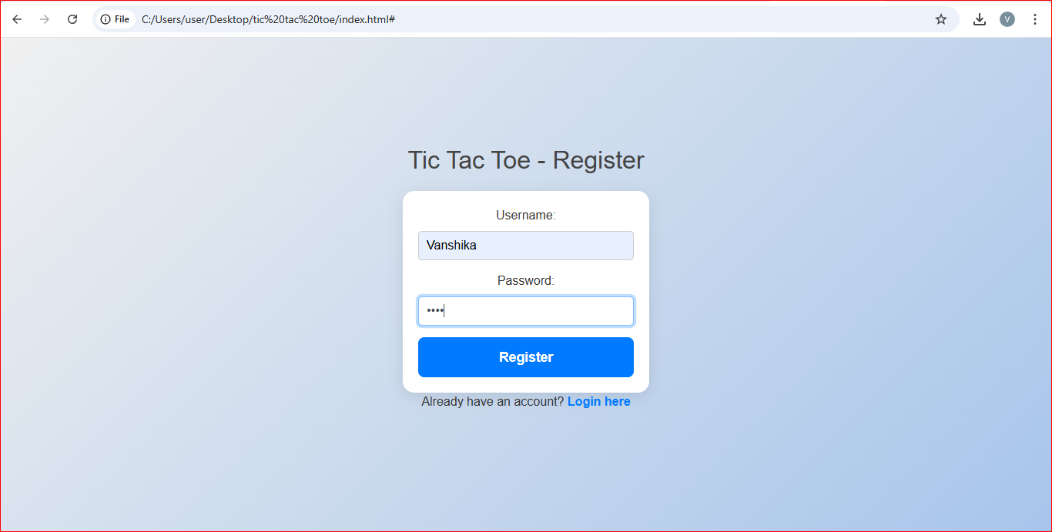

**LOGIN**

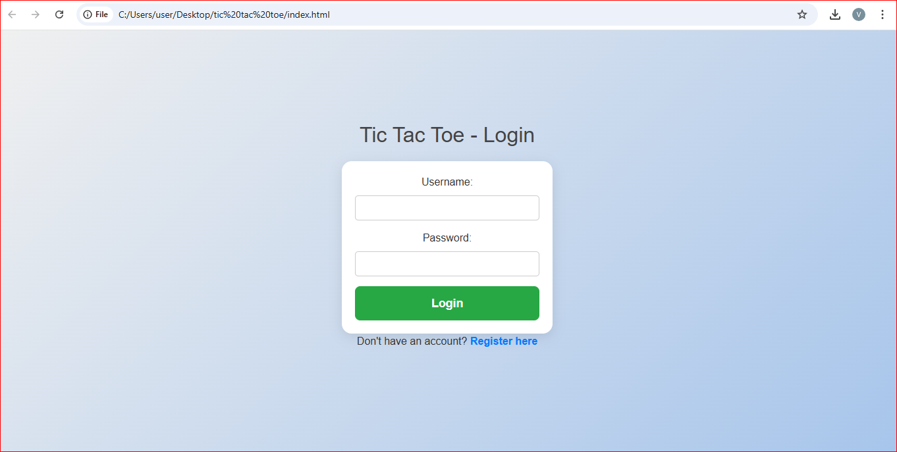

**ONE PLAYER MODE**

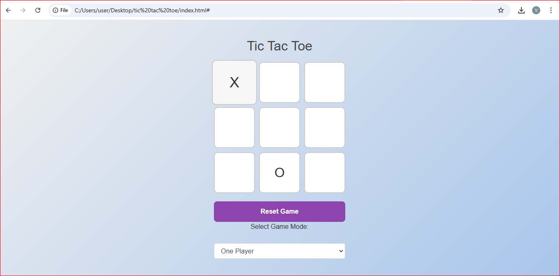

**WINNER**

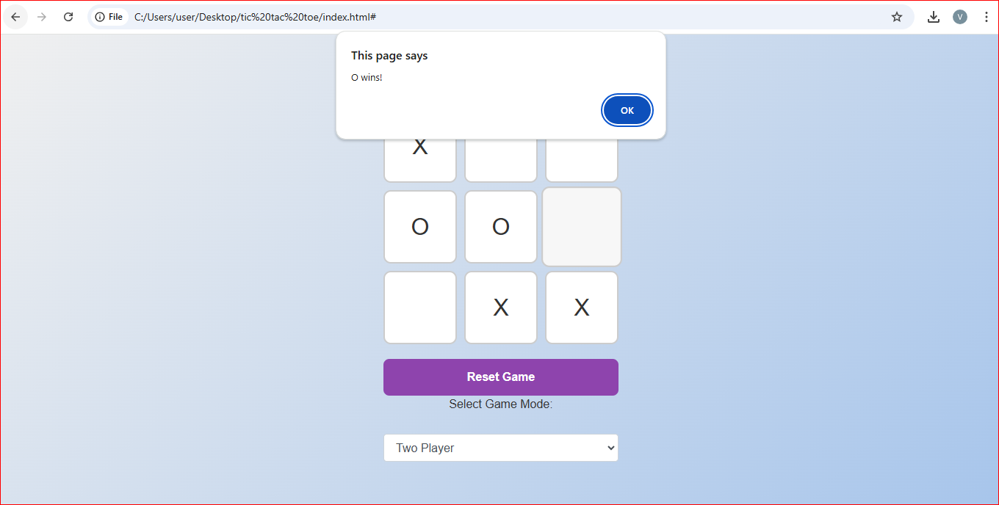

## ****6. Login Page****

**Innovative Features**

* **User-Friendly Design**: Clean interface with intuitive fields for login and registration.
* **Error Handling**: Displays specific messages for invalid credentials or failed logins.
* **Data Validation**: Enforces secure and sanitized inputs to prevent SQL injection.

## ****7. Challenges and Solutions****

**Challenge 1: Real-Time Gameplay Synchronization**

* **Problem**: Synchronizing moves between two players in real time.
* **Solution**: Implemented session-based state management and AJAX-based requests for smooth updates.

**Challenge 2: Handling Game State Across Sessions**

* **Problem**: Preserving game state when sessions expire or reset.
* **Solution**: Designed a scalable architecture to handle state persistence using session attributes.

**Challenge 3: Cross-Browser Compatibility**

* **Problem**: Ensuring consistent UI across different browsers.
* **Solution**: Adopted CSS normalization and thorough testing on major browsers like Chrome, Firefox, and Safari.

## ****8. Conclusion and Future Scope****

**Conclusion**

The Tic Tac Toe project successfully demonstrates the integration of **Java Servlets**, **JSP**, and **Maven** for developing interactive web applications. It provides a user-friendly platform for gameplay with efficient session management and clean design.

**Future Scope**

* **Enhanced Multiplayer Features**: Enable remote multiplayer support using WebSockets.
* **AI Integration**: Add a single-player mode with an AI opponent.
* **Analytics Dashboard**: Introduce game statistics like win/loss ratios for users.
* **Mobile App Development**: Expand the project into a cross-platform mobile application using frameworks like Flutter or React Native.